A fair chance for all
Breaking the cycle of persistent disadvantage
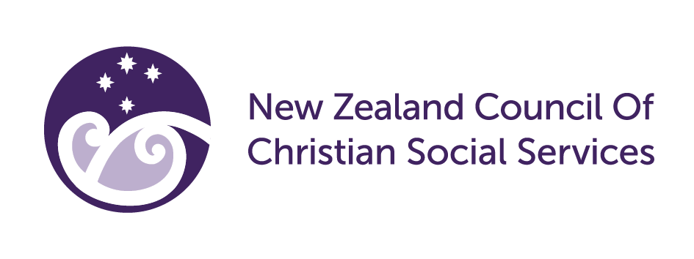

Summary of Interim Report | October 2022
The Productivity Commission has released its Interim Report on the findings of its A fair chance for all: Breaking the cycle of persistent disadvantage research, which NZCCSS submitted on in August 2021. Our submission recommended exploration of systemic and economic change, enactment of Te Tiriti o Waitangi, and exploration of a sustainable, effective and valued peoples workforce. You can read our submission here.
The Interim Report indicates that about 17% (724 000) of New Zealanders experienced persistent disadvantage in both 2013 and 2018. The Commission defines disadvantage using three domains that align with the absence of mauri ora:
• left out (exclusion or lacking identity, belonging and connection);
• doing without (deprivation/material hardship or lacking aspiration and capability); and
• income poor (income poverty or lacking the foundations to grow prosperity).
“Sole parents, people from families with no high school qualifications, Māori, Pacific peoples and disabled people were generally between one-and-a-half and three times more likely to experience persistent disadvantage in one or both of the two domains than the average New Zealand population under 65 years.”
The Commission has established a broad vision for social inclusion drawing from He Ara Waiora – a tikanga framework:
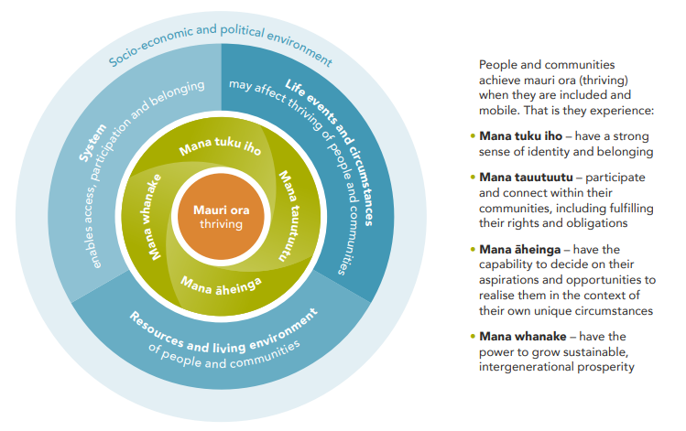
The Commission has sought to understand the system barriers within the public management system that contribute to people experiencing persistent disadvantage.
Four drivers of disadvantage within the system have been identified: power imbalances, discrimination, and the ongoing impact of colonisation, siloed and fragmented government, short-termism and status-quo bias.
1 He Ara Waiora from Interim Report Overview, pg.2
The following are the Commission’s interim recommendations for addressing barriers and achieving a fair chance for all:
- Re-think overall system settings to prioritise equity, wellbeing and social inclusion
- Re-focus public accountability settings to activate a wellbeing approach
- Broaden and embed a wellbeing approach across policymaking and funding frameworks
- Enable system learning and improvement through monitoring and evaluation
Opportunities to engage further:
1. Read the full report and related research here.
2. You can watch the Commission’s presentation of Interim Findings here.
3. Attend a Panel Webinar on 26th October: Perspectives on fair chance for all interim report
Speakers on 26 October
- Dr Penny Hagen, Director Tangata Tiriti, Auckland Co-Design Lab
- Angie Tangaere, Kaitohu Tangata Whenua, Auckland Co-Design Lab
- Tunumafono Fa'amoetauloa Avaula Fa'amoe MNZM, Board Member Vaka Tatua, Founder Tōfa Mamao
- Eruera Tarena, Tokona Te Raki / Māori Futures Collective

4. Submissions on Interim Report due 11 November 2022 – NZCCSS welcomes your feedback on the report for inclusion in our submission.
The Commission will present its final advice to Government in March 2023.

A fair chance for all Interim Report – Overview, pg.3
Note: The Report measures people aged 5-64 years so does not capture disadvantage in later life. There is some research into the impacts of disadvantage on children’s outcomes using the Growing Up in New Zealand study here.
Note: The Interim Report measures only ‘being income poor’ and ‘being left out’, but the final report aims to measure all three domains.
As above

